Guillermo Martín-Coello Juárez

Grupo 149

Computación de Altas Prestaciones

**Exercise 1**

Part A

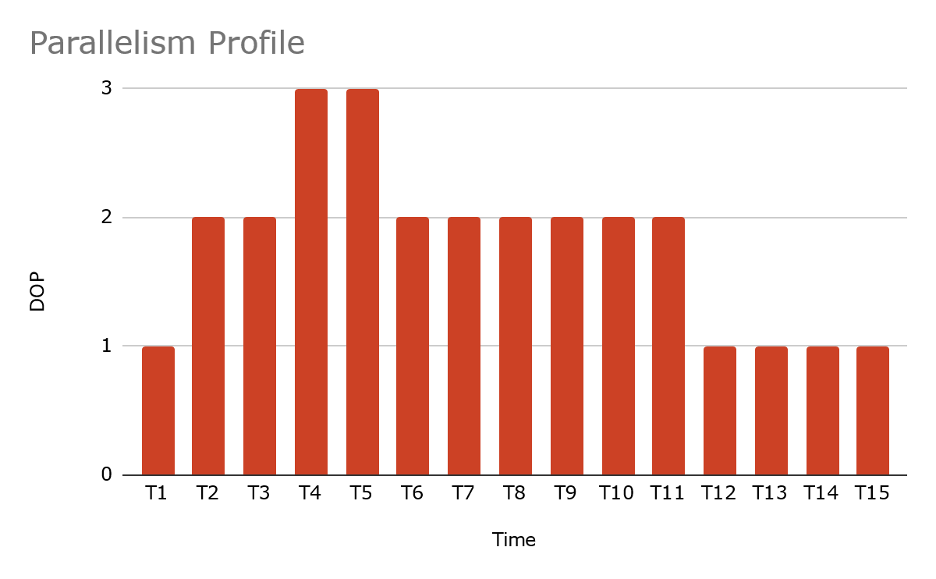

Part B

As we can see in the previous graph, the maximum degree of parallelism reached is 3. The amount of work done with this degree of parallelism is 6.

Part C

Speedup is S = Ts / Tp

Ts = 27

Tp = 15 (for p = ∞)

S = Ts / Tp = 27 / 15 = 1.8

We know the maximum degree of parallelism reached is 3, so the Speedup for S(∞) and S(p=4) will be the same, 1.8.

For S(p=2), Tp is calculated (17) and DOP is compared to the others:

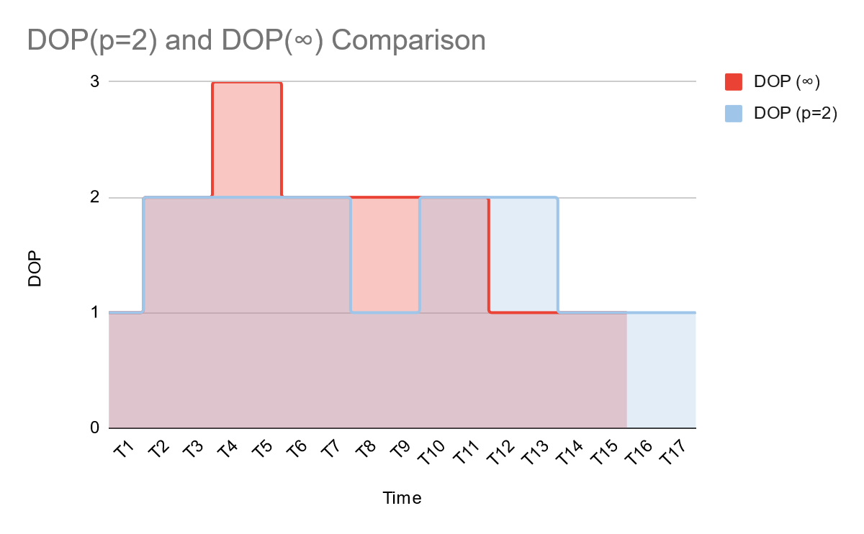

S = Ts / Tp = 27 / 17 = 1.5882.

Comparing results, S(∞) and S(p=4) have a bigger Speedup than S(p=2).

Part D:

As we know, E(n) = S(n)/n,

S(∞) and S(p=4) is 1.8.

S(p=2) is 1.5882.

S(p=1) is 1.

E(∞) and E(p=4) are equal to E(p=3) (the maximum degree of parallelism) and is 1.8 / 3 = 0.6.

E(p=2) is 1.5882 / 2 = 0.7941.

E(p=1) is 1 / 1 = 1.

